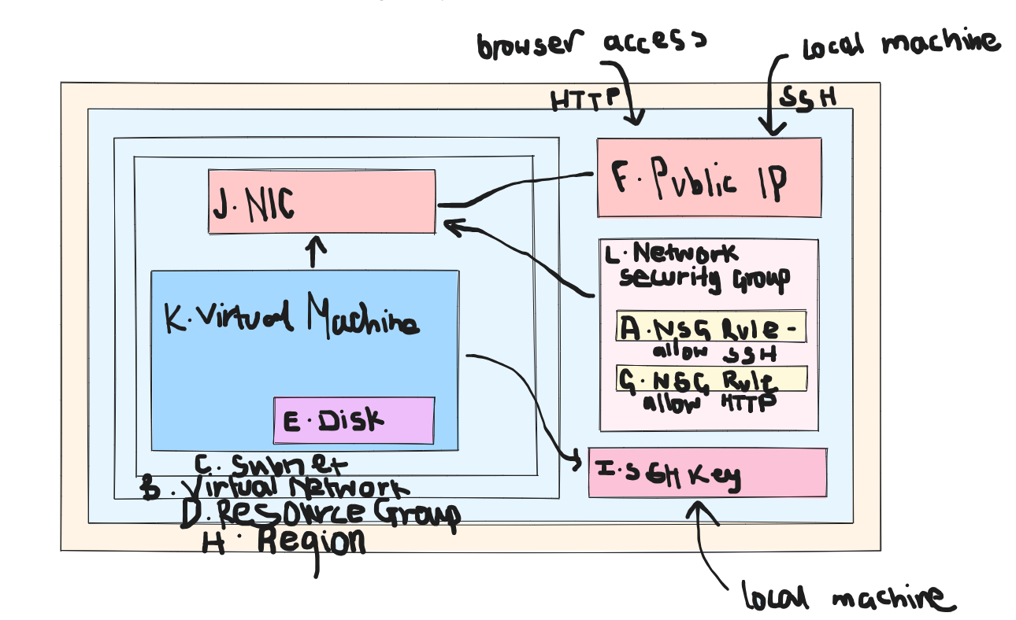
L. like the security system on the computer
H. where everything lives
D. like a container to organise everything you have
E. stores the files for the VM
F. your public address
C. like a room inside a house
B. like the house (structure)
I. like a padlock on the computer
K. like a computer/device within a room
A, G. rules to decide what types of people (traffic) can access the computer
J. communicate with the computer through this

